Adjusting Notification Settings

There are several areas within HipChat you can adjust your settings. There are the Global Notification Settings, the Application Settings, and the Room Settings. We’ll go through each one and explaining what each one controls and how to change the settings.

Global Settings
Global Settings will affect notifications from every room and 1-on-1 message. Changing these settings is useful when you want to update how your receive notifications for everything.

- Within the HipChat application, select your profile image and click Profile. (Figure 1)
- This brings up the HipChat website. You may have to login again. On the left side of the screen, select Notifications. (Figure 2)
- To the right are several options. You can control specifically whether your receive notifications for various messages and whether you receive an email or phone notification. (Figure 3)

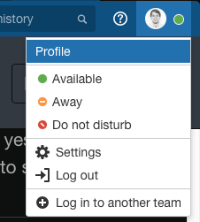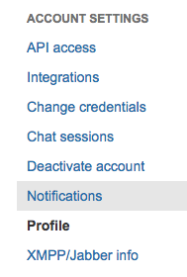
Figure 1 Figure 2

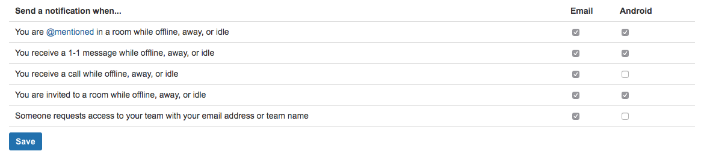
Figure 3

Application Settings
Application Settings affect your HipChat app specifically. To change the settings on the application level:

- Select your profile image and click Settings.
- This brings up a pop-up menu with various options.
  - Under the Notifications tab, you can adjust how you want to be notified of messages. For example, you can deselect the Play sound for message and video notifications to prevent your computer from beeping whenever a HipChat message is sent out. Alternatively, you could select Quiet to only be notified when messages are sent directly to you. (Figure 4)
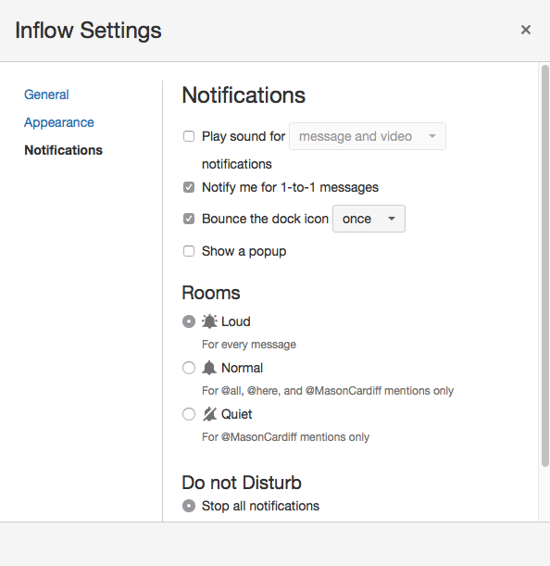
Figure 4

Room Settings
The room settings effect only the specific room being modified. This allows you to change how you receive notifications on a room-by-room basis. Begin by first selecting the room you want to modify.

- Select the Bell Icon. The following dialogue box will appear with various options. (Figure 5)
  - If there is a particular room you do not want to receive notifications in, you can change it to Quiet. For example, let’s say you don’t want to engage in the Fitness room, but love exchanging Books in the Reading Room. You can keep the notification on Loud for the book room, but turn the setting to Quiet in the Fitness room. This allows you to stay engaged in the topics you’re interested in while not being notified of messages in the rooms you’re not.
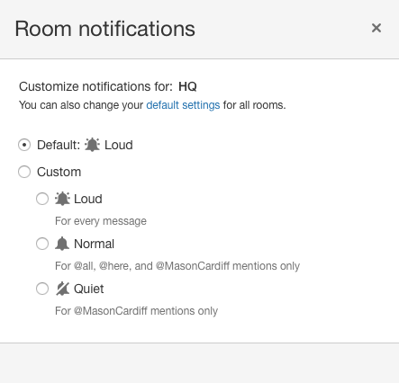

Phone Notifications
The HipChat mobile app also has a means to change how you receive notifications on a room by room basis.
- Tap > Settings. (The icon isn't visible in a chat, so tap the back arrow if you can't see it).
- Choose how you'd like to be notified (sound, vibrate, or both).

Additionally, you can modify the notifications through your Notifications Settings within the phone’s menus.

Android
- Click on the Settings Icon
- Tap Notifications
- Scroll or search through your apps for HipChat. Tap it.
- From here, you can begin selecting and deselecting which rooms you do or do not want to receive notifications for.
NOTE: It appears to only show a limited number of rooms and conversations, perhaps your most recent conversations.

Got Questions?
Reach out to @ChrisYoung in the IT HelpDesk room for support on adjusting your notifications.

